# Lab Exercise 13: JOB MANAGEMENT

|  |
| --- |
| Enable Job Sch.  Sample Batch App  Run Batch |

## Enable Job Scheduler

## Install a sample batch application

## Run a batch job

Enable Job Sch.

Sample Batch App

Run Batch



**Task 1: Enable Job Scheduler**

**Step 1:** Navigate to “System administration>Job scheduler”.

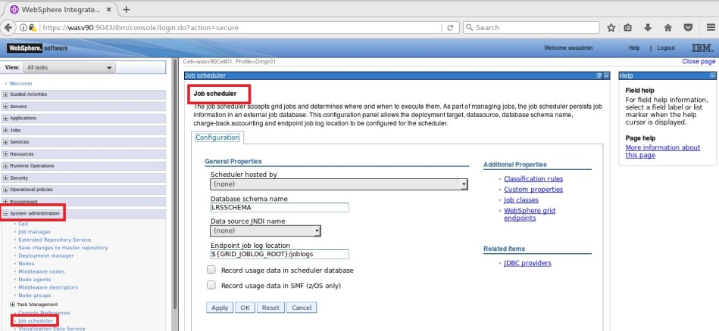

Enable Job Sch.

Sample Batch App

Run Batch



**Step 2:** Select the host to be used as scheduler and use “(none)” as JNDI name and click “OK”.

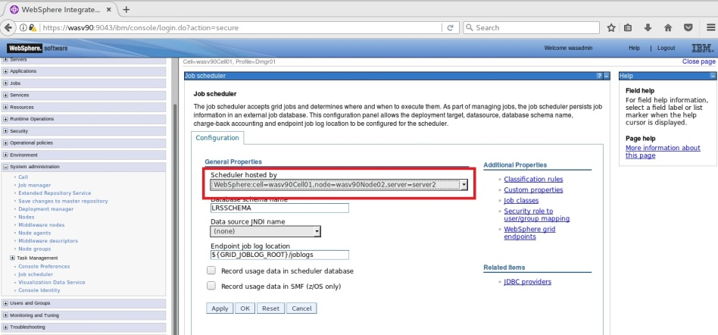

Enable Job Sch.

Sample Batch App

Run Batch



**Step 3:** Click “Save” to write changes. Please pay attention that “jdbc/lnsched” is created and selected automatically.

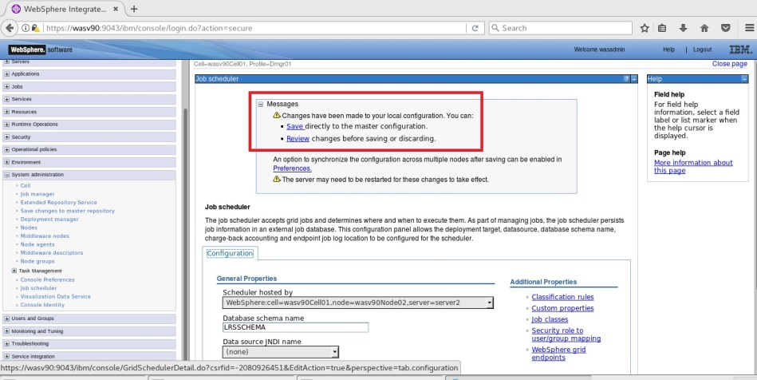

Enable Job Sch.

Sample Batch App

Run Batch



**Step 4:** Click on “Security role to user/group maping”.

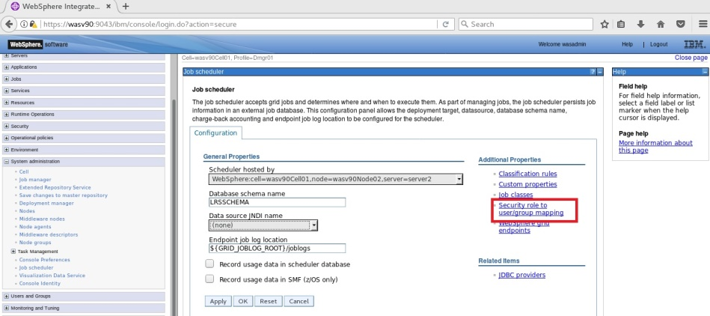

**Step 5:** Select all the roles and click “Map users”.

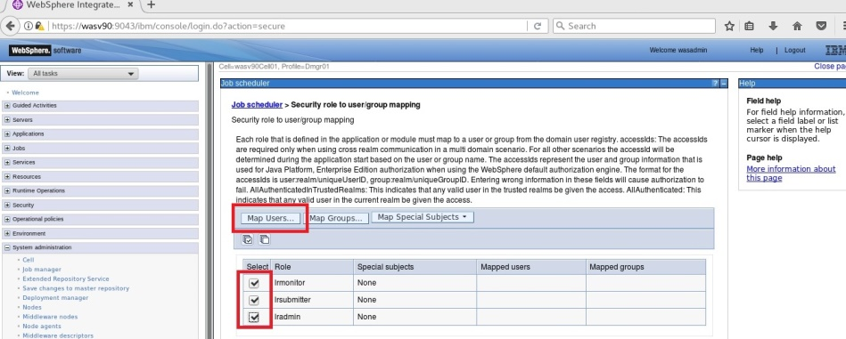

Enable Job Sch.

Sample Batch App

Run Batch



**Step 6:** Search the administrative user and using arrows add to the selected area and click “OK”.

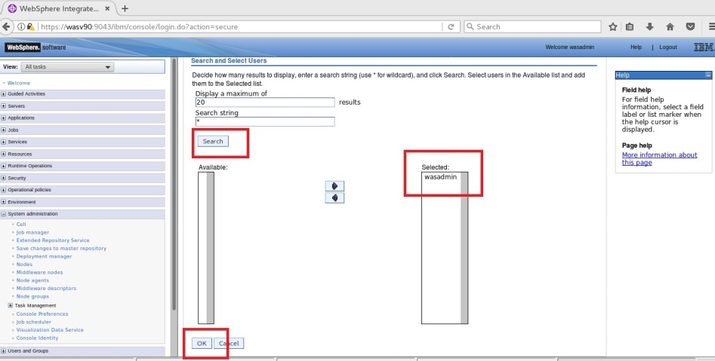

Enable Job Sch.

Sample Batch App

Run Batch



**Step 7:** Click “OK”.

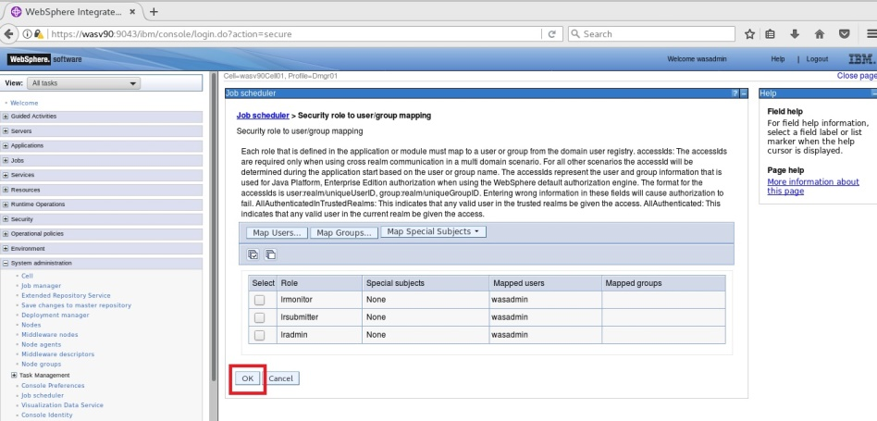

**Step 8:** Click “Save” to write changes.

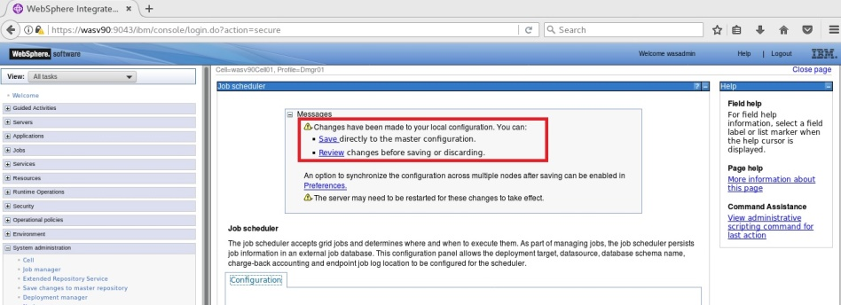

Enable Job Sch.

Sample Batch App

Run Batch



**Step 9:** Navigate to “Servers>Server Types>WebSphere application servers” and select the job scheduler host and click “Restart”.

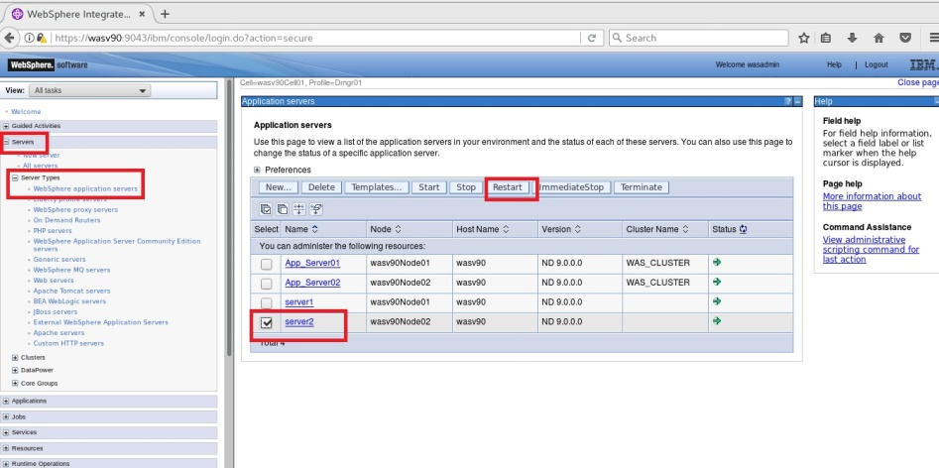

Application server must be restarted successfully.

Enable Job Sch.

Sample Batch App

Run Batch



**Step 10:** Check “WC_defaulthost_secure” port under “Ports” for the job scheduler hosting application server.

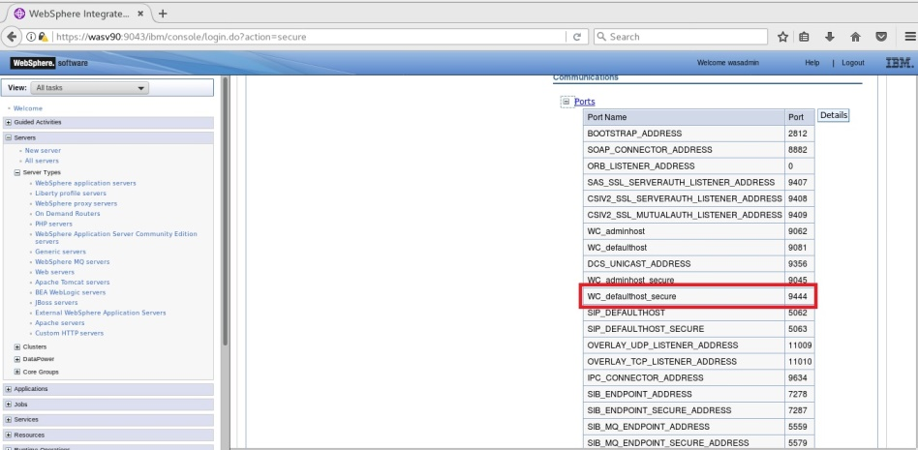

Enable Job Sch.

Sample Batch App

Run Batch



**Step 11:** Navigate to “https://wasv90:9444/jmc”.

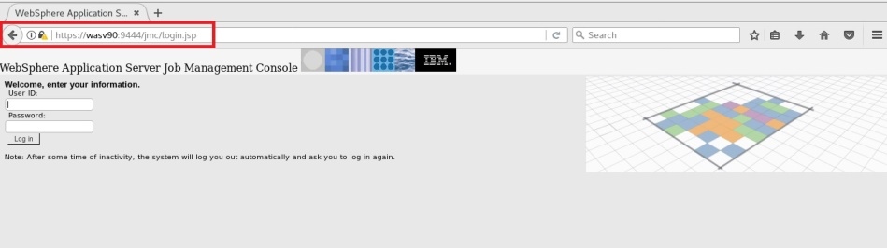

You should be able to login using administrative username and password.

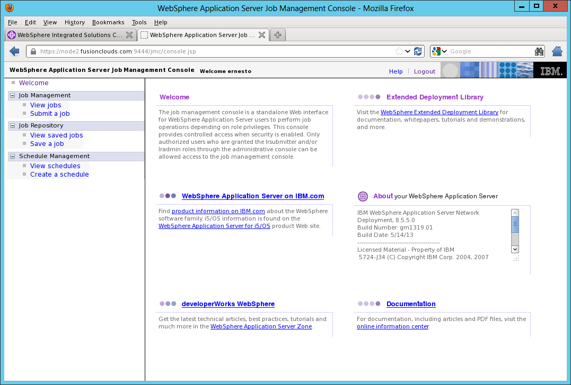

**Task 1 is complete!**

Enable Job Sch.

Sample Batch App

Run Batch



**Task 2: Install a sample batch application**

**Step 1:** Unzip the sample_ivt.zip to “/opt/IBM/”.

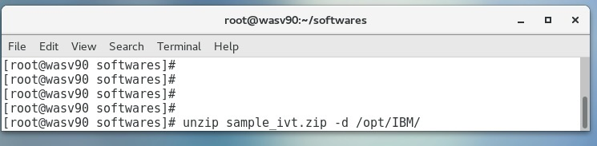

Enable Job Sch.

Sample Batch App

Run Batch



**Step 2:** Change directory to “/opt/IBM/WebSPhere/AppServer/derby/databases” and run “java –Djava.ext.dirs=/opt/IBM/WebSphere/AppServer/derby/lib –Dij.protocol=jdbc:derby: org.apache.derby.tools.ij /opt/IBM/IVT/scripts/CreateIVTTablesDerby.ddl”.

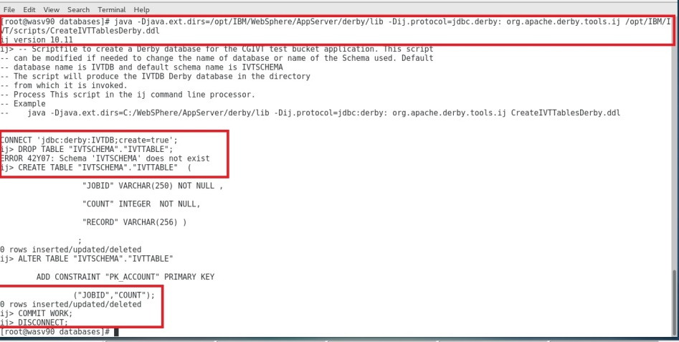

Enable Job Sch.

Sample Batch App

Run Batch



**Step 3:** Navigate to “Resources>JDBC>JDBC providers” and click “New”.

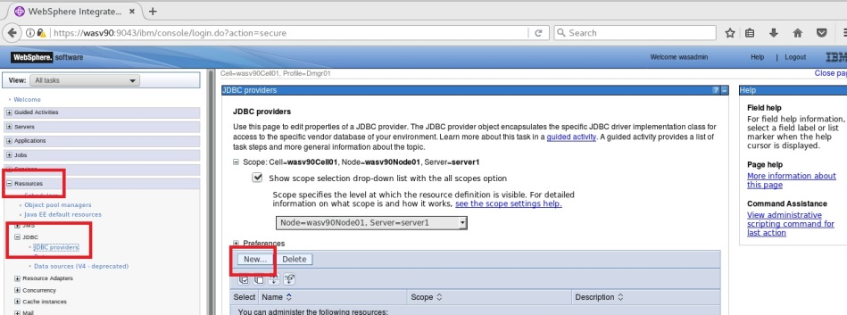

**Step 4:** Add a “Derby” database as follows.

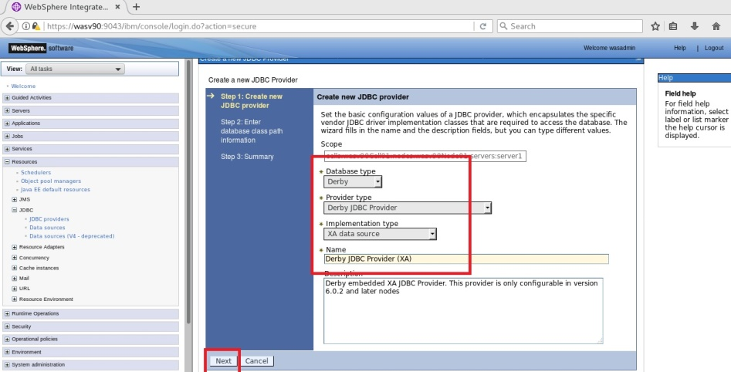

Enable Job Sch.

Sample Batch App

Run Batch



**Step 5:** Click “Finish” to complete.

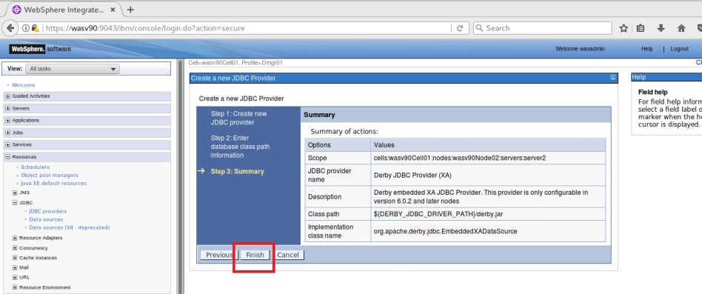

**Step 6:** Click “Save” to write changes.

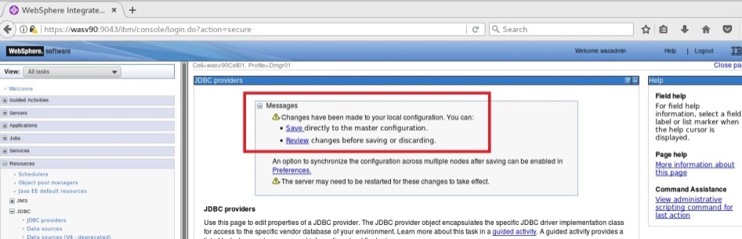

Enable Job Sch.

Sample Batch App

Run Batch



**Step 7:** Navigate to “Resources>JDBC>Data sources” and click “New”.

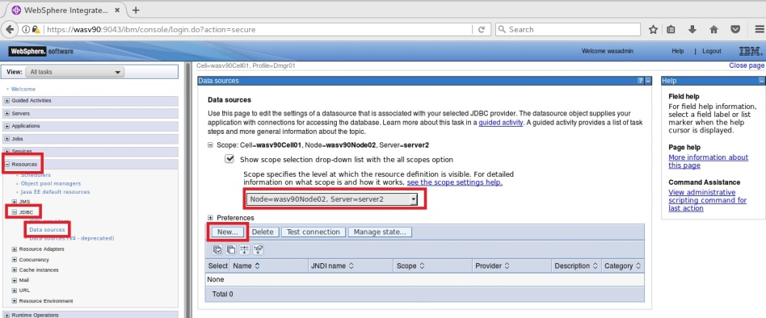

**Step 8:** Use “jdbc/IVTdbxa” as JDNI name and click “Next”.

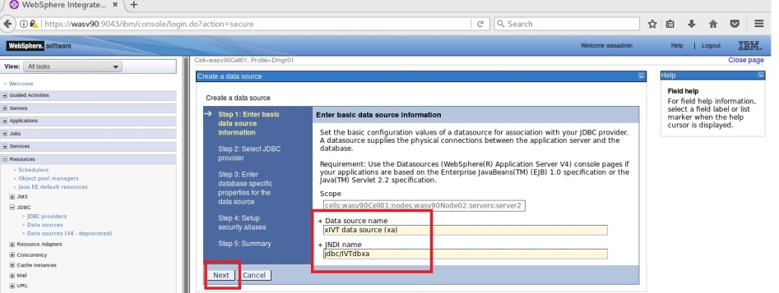

Enable Job Sch.

Sample Batch App

Run Batch



**Step 9:** Select “Derby JDBC Provider (XA)” and click “Next”.

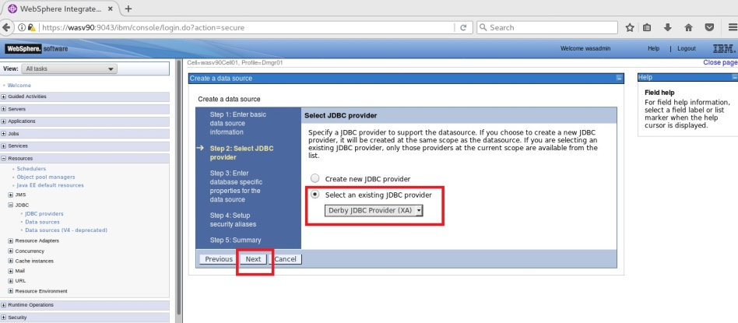

**Step 10:** Eneter “/opt/IBM/WebSPhere/AppServer/derby/databases/IVTDB” and click “Next”.

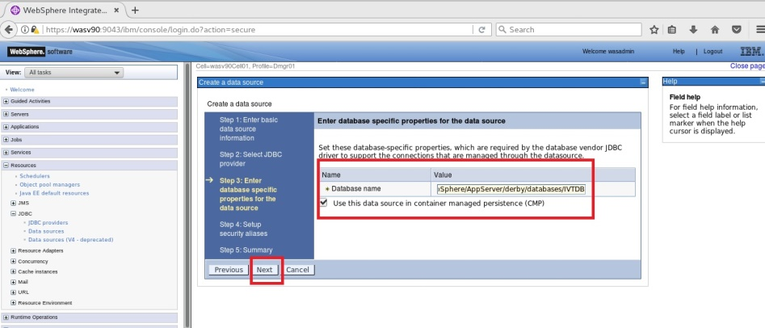

Enable Job Sch.

Sample Batch App

Run Batch



**Step 11:** Click “Next” to continue.

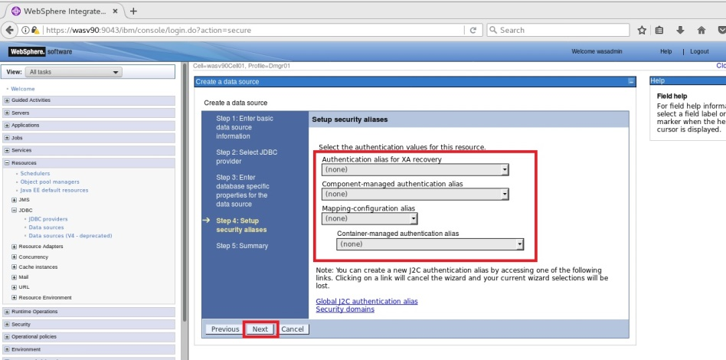

Enable Job Sch.

Sample Batch App

Run Batch



**Step 12:** Click “Finish” to complete.

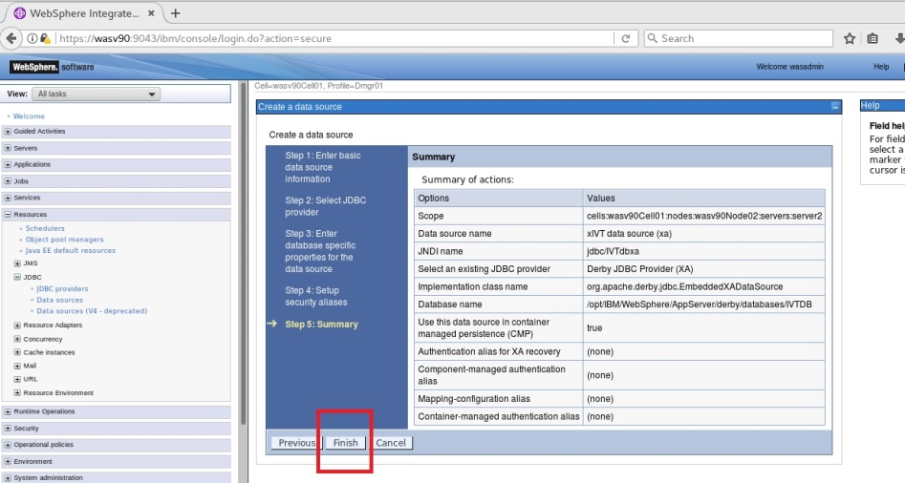

Select the new data source and click “Test connection” to verify the

database conencitvity.

Enable Job Sch.

Sample Batch App

Run Batch



**Step 14:** Navigate to “Applications>New Application” and click “New Enterprise Application”.

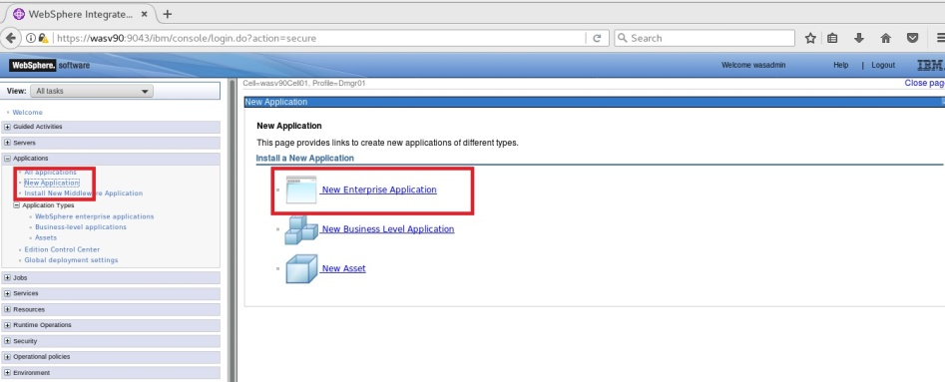

**Step 15:** Browse “/opt/IBM/sample_ivt/sample_ivt/IVT/installableApps/XDCGIVT.ear” and click “Next”.

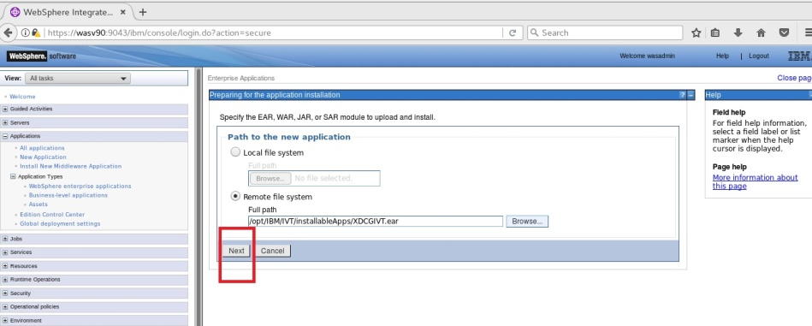

Enable Job Sch.

Sample Batch App

Run Batch



**Step 16:** Select “Fast Path” and click “Next”.

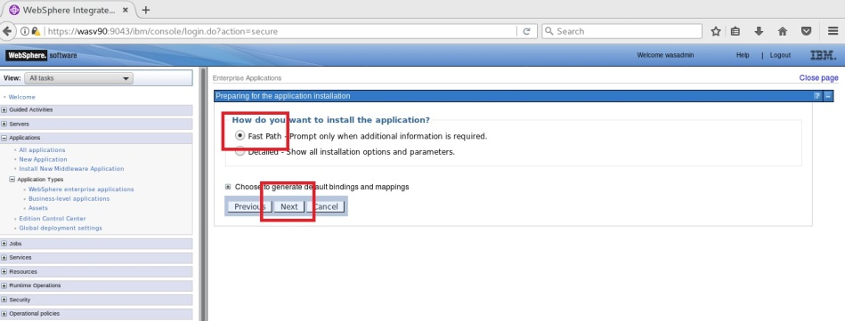

**Step 17:** Accept the default settings and click “Next”.

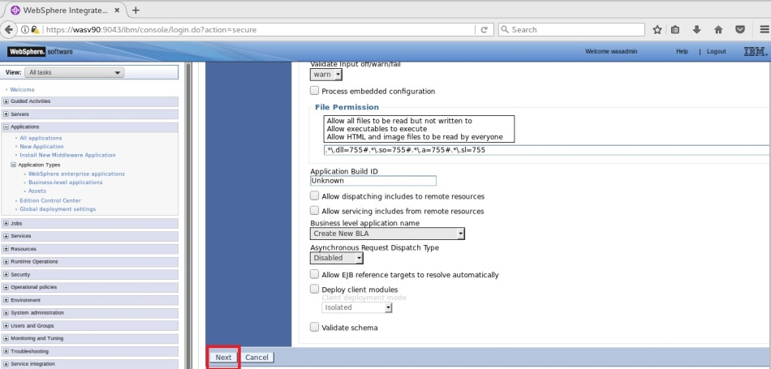

Enable Job Sch.

Sample Batch App

Run Batch



**Step 18:** Map the application to the application server selected as host of the job scheduler and click “Next”.

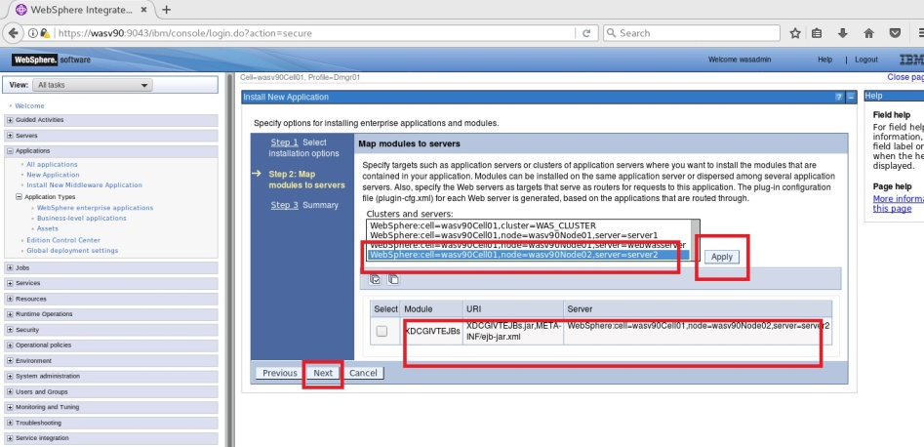

Enable Job Sch.

Sample Batch App

Run Batch



**Step 19:** Click “Finish”. You should see the success message then click “Save”.

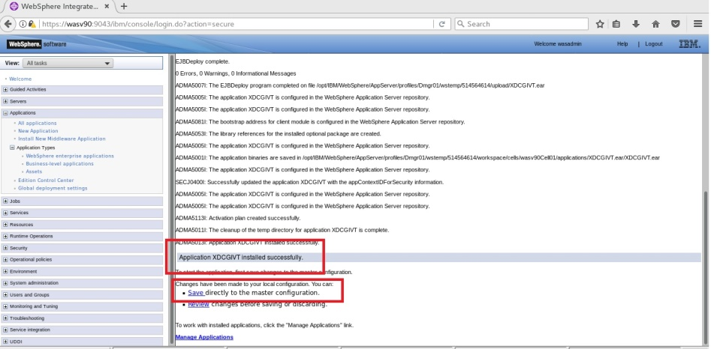

Enable Job Sch.

Sample Batch App

Run Batch



**Step 21:** Restart the application servers.

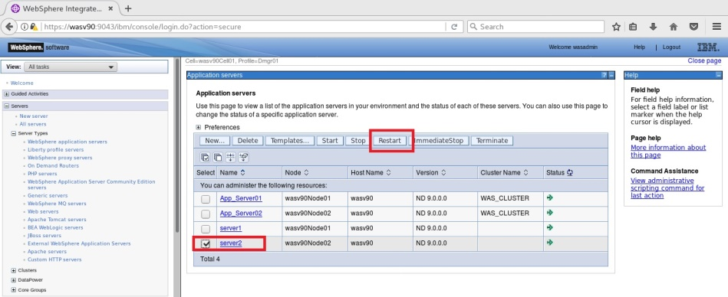

Make sure that restart is successful.

**Task 2 is complete!**

Enable Job Sch.

Sample Batch App

Run Batch



**Task 3: Run a batch job**

**Step 1:** Change "inputDataStream" and “outputDataStream” values according to your environment for the “XDCGIVTtxt2txtxJCL.xml”, “XDCGIVTbyte2bytexJCL.xml” and “XDCGIVTtxt2db2txtxJCL.xml” files under “scripts” folder.

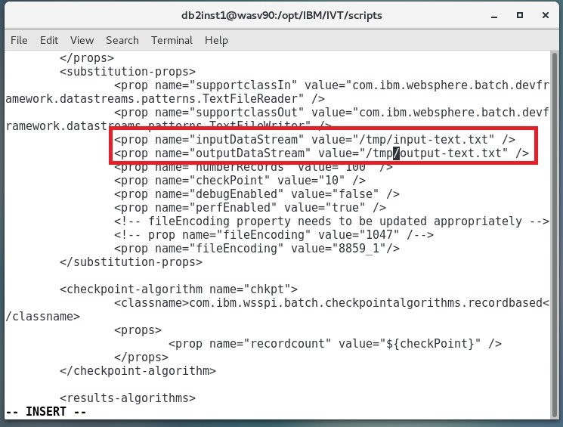

Enable Job Sch.

Sample Batch App

Run Batch



**Step 2:** Login to “Job Management Console” and click on “Submit a job”. Browse “XDCGIVTtxt2txtxJCL.xml” file in “Local file system” and select “Update substitution properties” and click “Submit”.

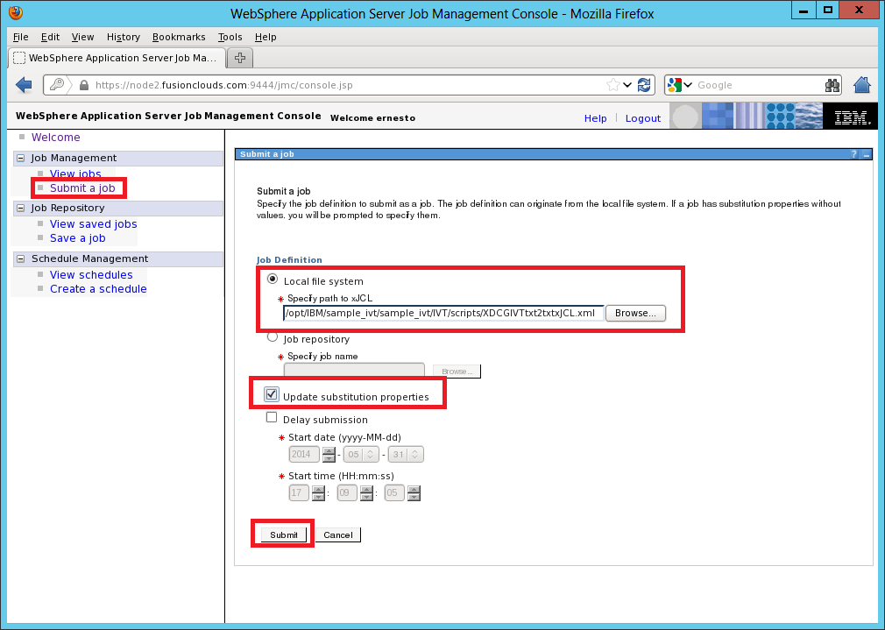

Enable Job Sch.

Sample Batch App

Run Batch



**Step 3:** You can change properties and click “OK”.

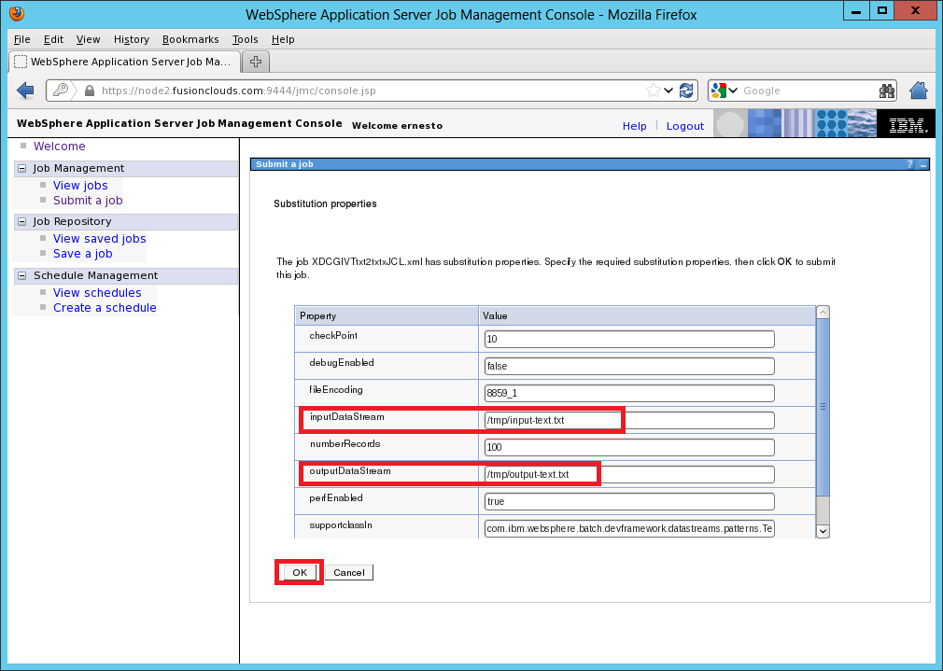

**Step 4:** You should see the job submission success message as follows.

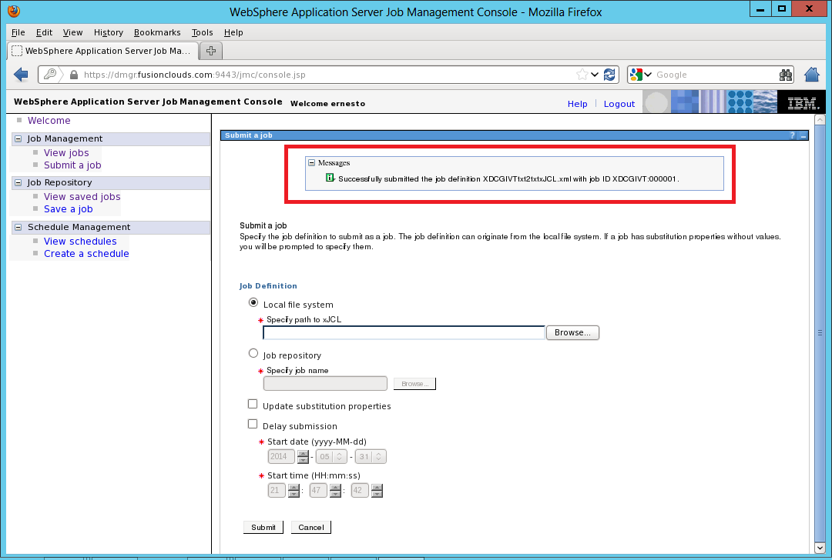

Enable Job Sch.

Sample Batch App

Run Batch



**Step 5:** You can take actions under “Job Management>View jobs” for the specific job.

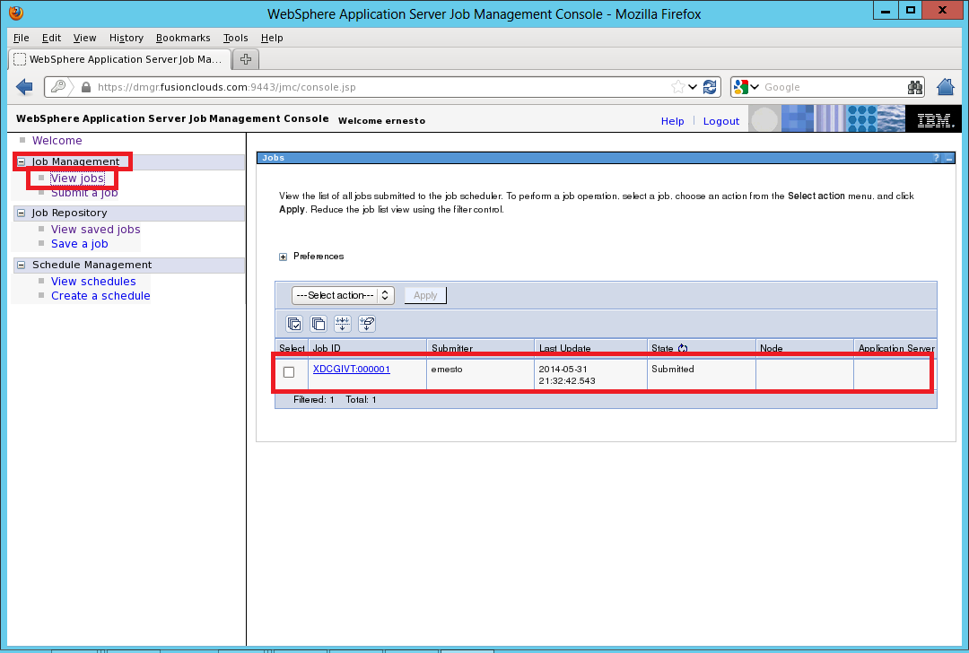

**Task 3 is complete!**

# SUMMARY

Batch applications are used to run complex and long tasks that contain typically transactional and multi-step processes. WebSphere Application Server uses an XML based language, xJCL, to provide consistent architecture that is optimized for Java and long running batch applications. A batch job contains directives to run one or more batch applications. Batch applications are Java EE applications that are designed to run in a non-interactive mode to complete business critical jobs.

# REFERENCES

* http://pic.dhe.ibm.com/infocenter/rsahelp/v8/index.jsp?topic=%2Fcom.ibm.servertools.doc%2Ftopics%2Fbatch%2Fr_profiletemplate_WAS8.html
* http://www.ibm.com/developerworks/websphere/techjournal/1106_alcott/1106_alcott.html

# INDEX

Batch applications 420

batch job 420

Job database 421

Job scheduler 421